AIM33 INSPECTION REPORT
Joint No. |  |  |  | COUPLER 25 |  |  | Report No. |  |  |  | KNDT-AIM-03-001
Drawing No. |  |  |  | COUPLER 25-G |  |  | Joint of Interpretation |  |  |  | Bad fusion interface or  foreign material
Ultrasonic Tester  Serial No. |  |  |  | 1040103032003050211 |  |  | Transducer  Serial No. |  |  |  | 275-K-818A / 7.5 ㎒.
Inspector Name |  |  |  | YONG HYEON, YU |  |  | Inspection Date |  |  |  | 2003. 10. 15
Image Capture Location: Image Capture Start Point (No.1): 20mm From Right side of Electrode
25-A1 |  | ■A □B / ■1 □2 □3 □4 / □C1 □C2 ■C3 |  |  |  | 25-A2 |  |  | ■A □B / □1 ■2 □3 □4 / □C1 □C2 ■C3
Interpretation |  |  | Bad fusion interface or foreign material |  |  | Interpretation |  |  |  | Voids or foreign material
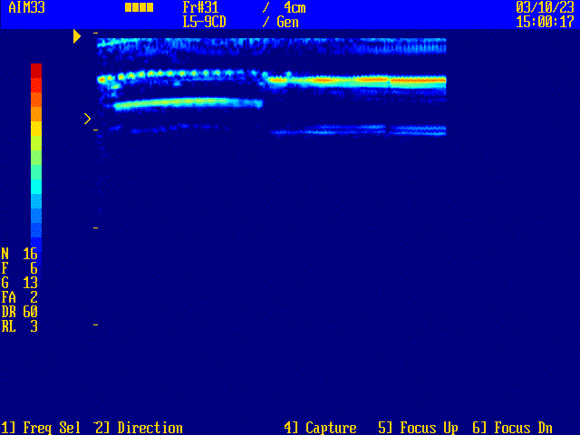 |  |  |  |  |  | 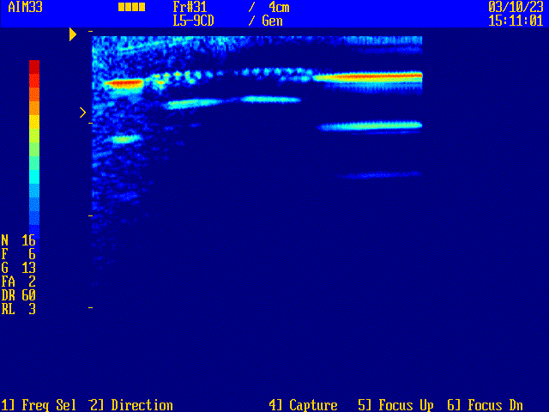
25-B1 | □A ■B / ■1 □2 □3 □4 / □C1 □C2 □C3 |  |  |  |  | 25-B2 |  | □A ■B / □1 ■2 □3 □4 / □C1 □C2 ■C3
Interpretation |  |  | No recordable indication |  |  | Interpretation |  |  |  | Voids or foreign material
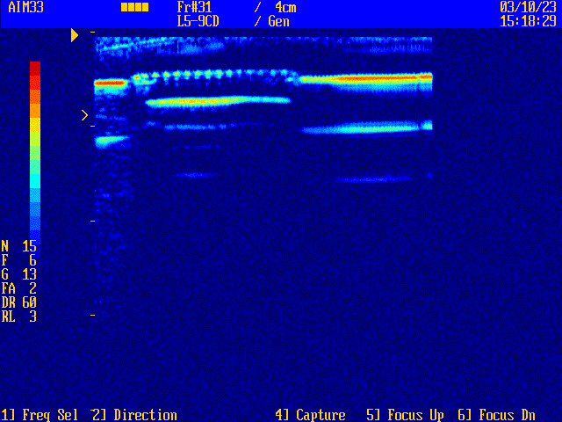 |  |  |  |  |  | 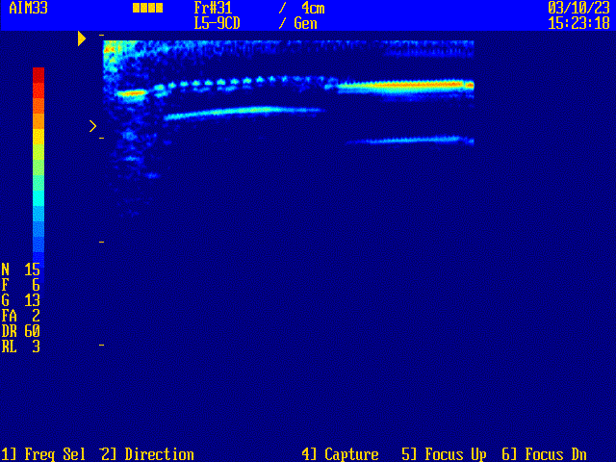
KNDT Form No. PER-①-A (A4 210 297㎜) KNDT&I Co.,Ltd.

Flow
“A” Part
“B” Part
1
2
3
4
0mm
1
2
3
4
90°
C1
C3
C2
Wire
Pipe
Coupler

